Daniel Cristea, Félix Allard

**Project Proposal - Flappy Bird**

**Github Repository**

<https://github.com/AlexCristea04/AndroidFinal2024>

**Project Description**

We are going to be creating a Flappy Bird clone, including a leaderboard, randomly placed obstacles, and identical movement mechanics to the original game. It will also use similar or identical assets to the original game, from the bird itself to the scrolling background. The player will be controlling a bird who can only flap its wings to move vertically, while horizontally randomized pipes scroll from right to left. The player must narrowly avoid the pipes, each pair of pipes passed giving one point. There is no way to win the game, the player must survive as long as possible until they hit a pipe, which leads to a fail state. When a run is finished, there is the option to upload initials and your score to an external database, which is displayed in an in-game leaderboard that can be accessed from the title screen. If we have the time, we would like to iterate further on the base mechanics of the original game, perhaps adding power-ups or new environments that have different and more challenging obstacles to avoid. But, for now, we will focus on implementing the essential mechanics and menus.

**Wireframes**

**MAIN MENU LEADERBOARDS**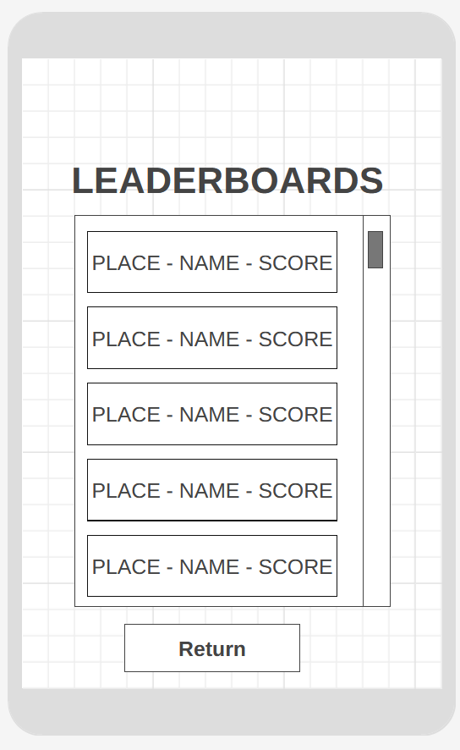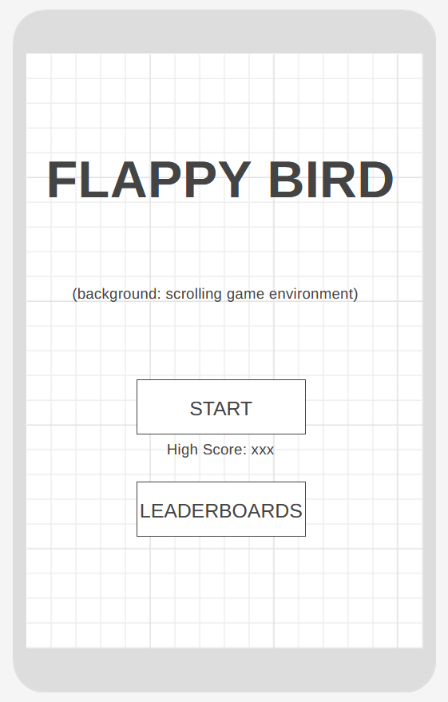

**GAME SCREEN GAME OVER SCREEN**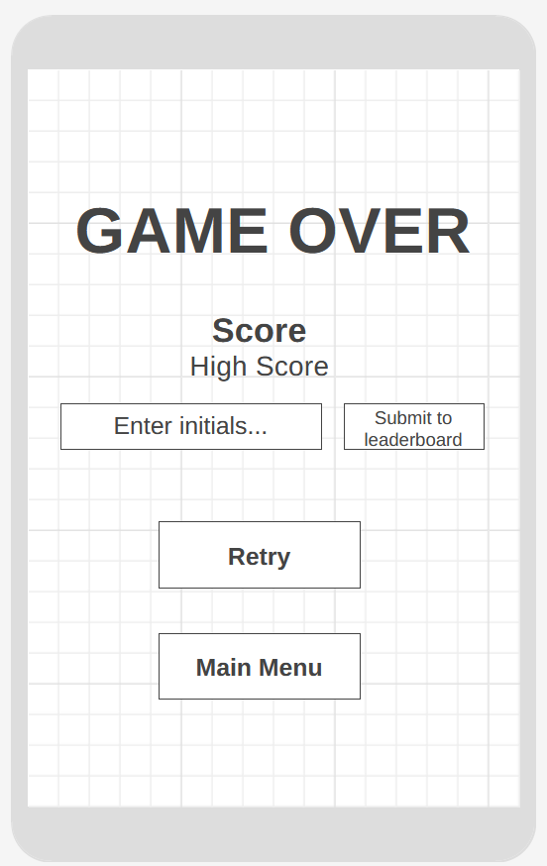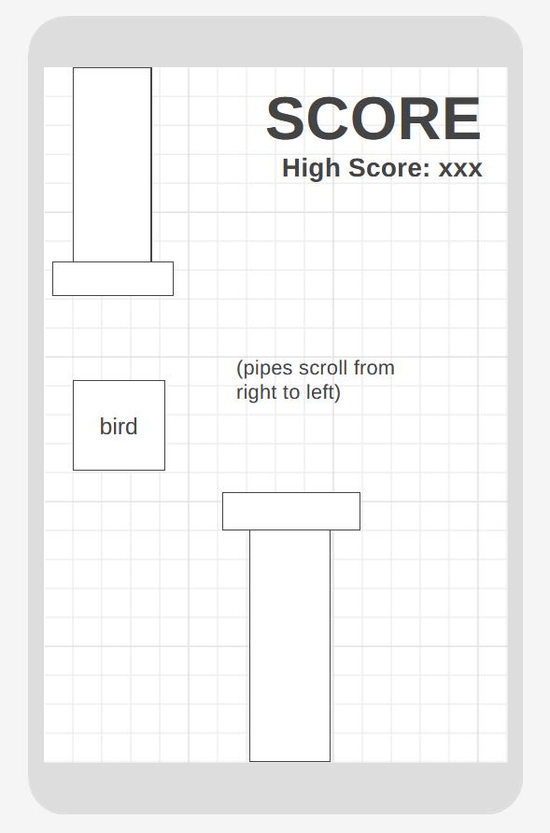

**Complexity Requirement**

We will be using SQL to store player scores in a database, which will be sorted by highest scores and displayed on a leaderboard screen.